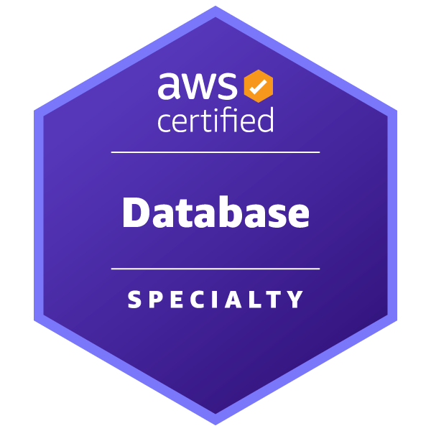
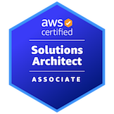
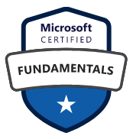
Name: Venkat Krishna
Email: venkatcloudengg@gmail.com
Contact Number: (209) 645-0126

- Sr. Cloud Database Engineer, Solutions Architect, Migration Specialist with over 15yrs of experience.
- Architected various database migrations from on-premises to cloud.
- Expertise Leading HA&DR solutions, migration and upgrades projects, DC failover automation.
- SQL Server Database Lead / Support lead managing team of 20 globally
- Strong communication skills

Technical skill set
- DBA – SQL Server, PostgreSQL, HADR, Migration, Upgrades, Optimizations
- Cloud – Aws, Azure
- Infrastructure – Windows, Linux
- Automation – Python, TSQL, Shell, PowerShell
- Software – Snowflake, Informatica, GitLab, Liquibase
Intuitive | AWS Solution Architect | Migration Lead Jun 2023 – Present
- Spearheaded the design and implementation of database migration strategies, orchestrating seamless transitions from on-premises environments to the cloud for both SQL Server and Postgres databases.
- Contributed to cutting-edge database innovations, meticulously documenting and onboarding applications onto AWS cloud infrastructure. Proficiently managed SQL Servers on EC2, AWS RDS, RDS Custom, and leveraged Aurora for both Postgres and BabelFish.
- Collaborated closely with application teams, gaining insights into front-end frameworks, and engineered tailored solutions to enhance overall system architecture.
- Led key initiatives such as DBOps streamlining, monitoring improvements, performance optimization techniques and cost optimization in S3, RDS, EC2 environments saving millions of dollars to the client.
- Automated AWS resource provisioning through Infrastructure as Code, utilizing tools such as Terraform and CloudFormation, streamlining deployment processes and enhancing efficiency.
- Standardized and improved the database deployment process by implementing Liquibase-based deployments in collaboration with end-users.
- Managed Snowflake databases, including optimizing storage and queries, resulting in significant improvements in performance and cost-efficiency.
- Built and optimized CI/CD pipelines in GitLab for continuous integration and delivery, streamlining testing, deployment, and automation of data workflows.
- Proof of concept on dbT, snowflake and informatica projects.

Amazon Web Services, Virtual| Sr. Database Consultant Jan 2022 – Jun 2023
- Customer facing skills to represent AWS, work with customer’s environment and drive technical and business discussions to design, modernize and migrate to AWS Cloud
- Participated in Agile SCRUM teams, contributing to development and deployment of data engineering solutions improving operational performance, reducing lead times, and enhancing productivity across teams.
- Work with customers to migrate database infra to AWS. This may include but is not limited to Re-Host database platform on AWS, Upgrade/Optimize for AWS, Re-Factor to open-source database platform on AWS.
- Proficient in handling traditional RDBMS (SQL Server, PostgreSQL) and NoSQL databases (MongoDB). Experience in integrating data from various systems.
- Worked with AWS gold customer for AWS as part of Cloud acceleration and mobilize engagement to evaluate data center evacuation understanding pros and cons about SQL Server on EC2 vs RDS SQL Server.
- Hands-on experience with cloud platforms like AWS, leveraging tools such as AWS SCT, DMS, S3, Cloud formation for large-scale data processing, migration and storage.
- Proof of concept experience on Airflow for orchestrating data workflows across various environments.

LinkedIn, Sunnyvale, CA | Sr. Database Site Reliability Engineer May 2016 – Dec 2021
- Responsible to manage LinkedIn and Lynda Database infrastructure on SQL Server, Oracle, MySQL and Azure Databases. Suggest improvements wherever required and improvise process as applicable.
- Assist, coach and migrated services from SQL server to LinkedIn Learning and Oracle to MySQL.
- Implemented CI/CD pipelines using GitLab for automated deployment and testing of data workflows, significantly reducing time to production and improving code quality.

Facebook, Menlo Park, CA | SQL Server Lead Database Engineer Oct 2014 – May 2016
- Architect, Design, Implement and Maintain SQL server instances across Facebook IT SQL Server Infrastructure.
- Lead multiple database projects on HADR and cross team collaboration expertise.
- Designed and implemented data models that significantly improved data processing efficiency and ensured data integrity, supporting real-time analytics across multiple platforms.

Chevron San Ramon, CA | SQL Server Lead DBA May 2013 – Sep 2014
- Operations and application support Lead for Credit card settlements, microfocus and internal applications.
- Project and database lead setting up SQL Server HADR and automated database refresh, DR, N/w issues etc.,

Microsoft, Hyderabad, India | Sr. SQL Server DBA Oct 2009 – Apr 2013
- Project - Enabling Platform Experience (EPX) - Sr. Database engineer managing MSDN, TechNet stack.
- Project - Clubbing - Support Lead, Sr. DBA SME, Release Lead for Microsoft Club Bing (www.clubbing.com)
- Project - Product Activation – Manage/support all Microsoft global Product Activations & HADR expertise.
JSSI, Chicago, IL | SQL Server Database consultant Sept 2008 – Feb 2009
- Production support, DR setup, Oncall, release management, code review, optimization and documentation.

CUNA Mutual Group, Madison, WI | SQL Server Database consultant. May 2008 – Aug 2008
- Database Lead, Release Engineer, DevOps, Process improvement, streamlined DB infrastructure workflow.

Motorola, Schaumburg, IL | Oracle-apps consultant. Oct 2007 – Jan 2008
- Oracle Apps Techno functional consultant working closely with O2C flow in SCM.

Siemens Medical Solutions, Malvern, PA | Database Intern July 2006 – May 2007
- Worked in the Product Management Group IT (Soarian IT) on SQL and Pl/Sql, database maintenance and QA.

Education
- Master of Science, Computer Sciences, PA – 2005-2007
- Bachelor of Technology, Computer Sciences and IT, India - 2001-2005

